Approval Request
Automated Network Request Management in ServiceNow
Date | 26 September 2026
Team ID | ________________
Project Name | Automated Network Request Management
Activity | Creation of Approval Request on Network Database Table
1. Purpose
The purpose of this activity is to configure an Approval Request related list for the Network Database table in ServiceNow. The configuration provides a dedicated place on the Network Database record where related approval records can be viewed. This supports clearer visibility of approval information during the network request management process.
2. Scope
This activity covers two configuration tasks: creating an Approval Request relationship and adding the resulting related list to the Network Database form. The work is limited to the configuration described in the project task. No Flow Designer workflow is included in this activity.
3. Work Performed
The Approval Request configuration is performed in two activities. First, a relationship is created to connect the Database table with the sysapprovals table. Second, the related list is added to the Network Database form so that the related approval records can be displayed.
4. Activity 1: Creation of Related List / Relationship
A relationship is created so that approval records can be associated with records in the Database table.
Step | Action | Configuration
1 | Navigate to | System Definition → Relationships.
2 | Create relationship | Click New to create a new relationship.
3 | Name | Enter: Approval Request.
4 | Applies to Table | Select: Database table.
5 | Queries from Table | Select: sysapprovals table.
6 | Active | Make sure Active is set to True.
7 | Save | Save the relationship.

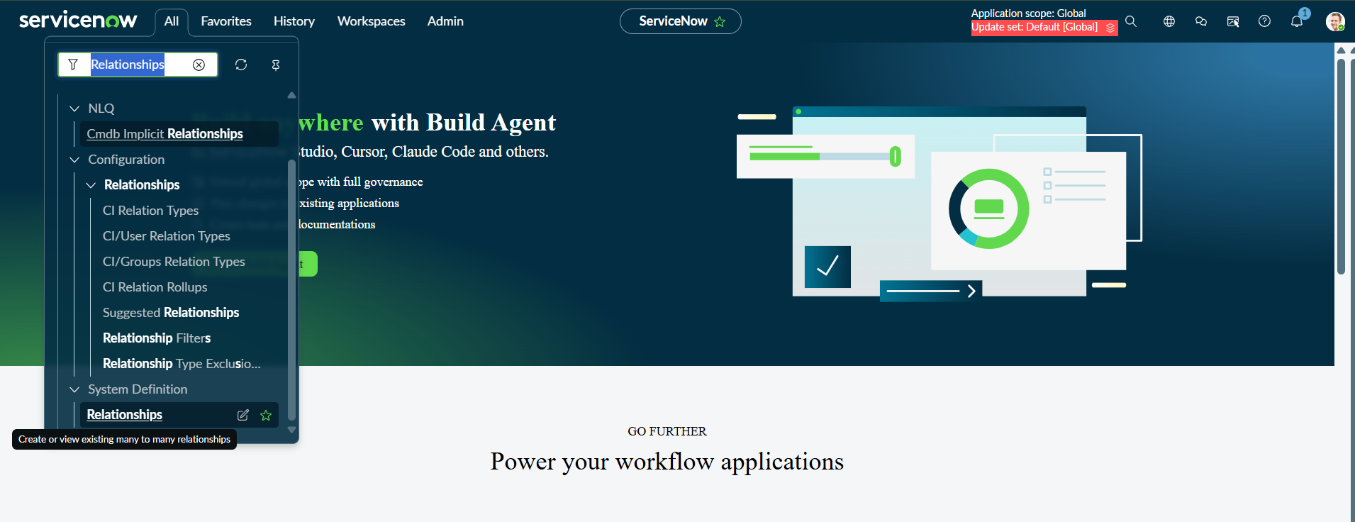
PDI Practice Image 1 – Approval Request Relationship Configuration
5. Activity 2: Adding Related List to the Table
A Related List displays records associated with the current record. After the Approval Request relationship is created, the related list can be added to the Network Database form so users can view the associated approval records directly from the record.

Step | Action | Details
1 | Open Form Designer | Navigate to Form Designer for the Database table.
2 | Add Related List | Add a Related List component/widget to the form.
3 | Select Related List | Select the Approval Request related list.
4 | Arrange | Place the related list in the required position on the form.
5 | Save | Save the form configuration and verify the result.

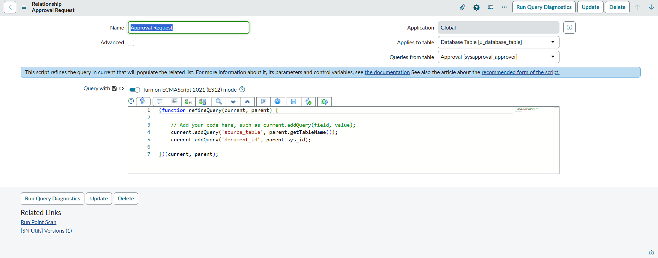
PDI Practice Image 2 – Related List Added to Network Database Form
6. Verification
After saving the configuration, open a Network Database record and verify that the Approval Request related list is visible on the form. The related list should provide access to the approval records associated with the selected record.
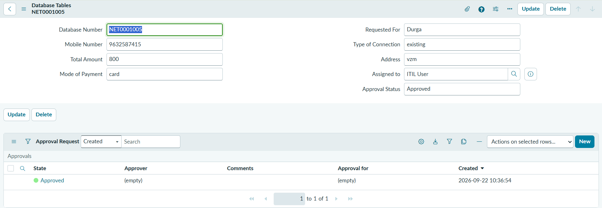
PDI Practice Image 3 – Network Database Record Showing Approval Request Related List
7. Benefits
Provides centralized visibility of approval-related records from the Network Database record.
Makes approval information easier to access while reviewing a network request.
Improves traceability between a network request record and its related approval information.
Provides a structured way to display related approval records on the ServiceNow form.
Supports clearer request administration and review.

8. Result
The Approval Request relationship and related list configuration provide a structured mechanism for displaying approval information on the Network Database table. The three PDI screenshots can be inserted at the marked locations to document the actual configuration and verification performed in the practice instance.
9. Conclusion
The Approval Request configuration improves the visibility and organization of approval information associated with Network Database records. By creating the relationship and displaying it as a related list, approval records can be accessed from the relevant network request record without requiring a separate navigation path. This activity establishes the approval-related data view required for the proposed network request management solution.

